Match Maker Matrimonial System

In the partial fulfillment for the award for the degree of

BACHELOR OF COMPUTER APPLICATION
Submitted by
- Name1 10CUSB0000
- Name2 10CUSB0000

ABC Degree College.
BANGALORE UNIVERSITY: BANGALORE - 560001

BONAFIDE CERTIFICATE
Certified that this project report “Match Maker Matrimonial System” is the bonafide work of “NITA PRADHAN & MITA who carried out the project work under my supervision.

SIGNATURE
PRINCIPAL SIGNATURE
ABC Degree College.
BANGALORE UNIVERSITY: BANGALOR-560001
CERTIFICATE
This is to certify that Mr. Name1 and Mr. Name2 has satisfactorily completed the project entitled “Match Maker Matrimonial System” under the guidance of Ms. Aruna for the academic year 2012 -2013.
_ _ _ _ _ _ _ _ _ _ _ _ _ _ _ _ _ _ _ _ _ _ _ _ _ _ _ _ _
Signature of the H.O.D Faculty in Charge
(Dept. of Comp. Sc.)

_ _ _ _ _ _ _ _ _ _ _ _
Principal Signature

Examiners:
1) _ _ _ _ _ _ _ _

2)_ _ _ _ _ _ _ _

Date: _ _ _ _ __ _ _ _ _
CONTENTS

1. Introduction
2. Objectives
3. Tools, Hardware & Software specification
4. Project Category
5. System Analysis
6. Design Document
7. Coding
8. Testing
9. Input and Output screens
10. Implementation of security
11. Limitations of the project
12. Future scope and further enhancement of the project.
13. Bibliography
Existing System and System Requirement

INTRODUCTION:
Match Maker Matrimonial is a software application to manage all match maker agent office. This project is designed to manage all the members who registered with match maker agent. It also takes care of all the payment transactions. This program will help the match maker agent work easier. The main feature of this project is matching the alliance based on the member requirement. The program will search all the existing members’ data to match the required criteria. Which is a very tedious and difficult process? Whereas this program will helps them to solve this problem very easily.

OBJECTIVE:
The main objective of the application is to automate the existing method of managing data manually to systematic storage of data, which can be searched any time as and when required. The other main objective of this application is to store all the player, match, ground details. The other main objective of this project is to show score board when the match is going on.

SCOPE:
This application is made for the match makers to the match alliance. So on successful implementation of this program in one place, it can be utilized by any match maker agent through out the country.

Existing System
Presently the match maker process is done through the manual method. Where we have lot of problems. It is no easy to mach many profile with instant of time. So client has to wait for long time to get the result.

The proposed system
The proposed system is a software application program to manage the matrimonial office day to day work. The software will be developed in Visual Basic 6.0 as front end and MS Access as a backend.

The proposed system will solve many problems faced by the matrimonial office at the movement. It stores all the information digitally so the information can be stored in a small place. Also the searching of this information is very fast. Also information can moved from one person to another person very quickly.

All calculations will done digitally so there will not be any arithmetic errors. Collecting money in the cash counter counting it and take a report will be very easy in the proposed system. The time spend earlier bring drastically down with this system.

Information is available in click of button so there is no problem of searching of files as said in the earlier system. Here all information available digitally so searching will be faster and easier.

Modules of the proposed system
- Login Form
- MDI Form
- Caste Entry form
- Sub Caste Entry Form
- Education Form
- The Boy Profile From
- Girl Profile Form
- Search Criteria Form
- Search Form:
- Send Letter Form
- Receipt Entry Form
- Reports
        - Customer Report
        - Send Letter Report
        - Receipt Report

Hardware and Software requirement

Hardware Requirement

Processor : Intel Core Duo 2.0 GHz or more
RAM : 1 GB or More
Hard disk : 80GB or more
Monitor : 15” CRT, or LCD monitor
Keyboard : Normal or Multimedia
Mouse : Compatible mouse

Software Requirement

Front End : Visual Basic 6

Back End : MS Access

Operation System : Windows XP with server pack 3
Or
Windows 7

SOFTWARE REQUIREMENT SPECIFICATION:
An SRS is basically an organization's understanding (in writing) of a customer or potential client's system requirements and dependencies at a particular point in time (usually) prior to any actual design or development work. It's a two-way insurance policy that assures that both the client and the organization understand the other's requirements from that perspective at a given point in time.
The SRS document itself states in precise and explicit language those functions and capabilities a software system must provide, as well as states any required constraints by which the system must abide. The SRS also functions as a blueprint for completing a project with as little cost growth as possible. The SRS is often referred to as the "parent" document because all subsequent project management documents, such as design specifications, statements of work, software architecture specifications, testing and validation plans, and documentation plans, are related to it.
It's important to note that an SRS contains functional and nonfunctional requirements only; it doesn't offer design suggestions, possible solutions to technology or business issues, or any other information other than what the development team understands the customer's system requirements to be.
A well-designed, well-written SRS accomplishes four major goals:
- It provides feedback to the customer. An SRS is the customer's assurance that the development organization understands the issues or problems to be solved and the software behavior necessary to address those problems. Therefore, the SRS should be written in natural language, in an unambiguous manner that may also include charts, tables, data flow diagrams, decision tables, and so on.
- It decomposes the problem into component parts. The simple act of writing down software requirements in a well-designed format organizes information, places borders around the problem, solidifies ideas, and helps break down the problem into its component parts in an orderly fashion.
- It serves as an input to the design specification. As mentioned previously, the SRS serves as the parent document to subsequent documents, such as the software design specification and statement of work. Therefore, the SRS must contain sufficient detail in the functional system requirements so that a design solution can be devised.
- It serves as a product validation check. The SRS also serves as the parent document for testing and validation strategies that will be applied to the requirements for verification.
SRS are typically developed during the first stages of "Requirements Development," which is the initial product development phase in which information is gathered about what requirements are needed--and not. This information-gathering stage can include onsite visits, questionnaires, surveys, interviews, and perhaps a return-on-investment (ROI) analysis or needs analysis of the customer or client's current business environment. The actual specification, then, is written after the requirements have been gathered and analyzed.

INFORMATION DESCRIPTION:

DETAIL DESCRIPTION OF THE PROBLEM:

At present all applications forms are managed manually, due to this a huge place is required to store all these application forms, apart from this searching particular application form is very difficult due to the large collection. So they require software which can provide quick access to all application forms and to process them step by step and paralelly the application status can be known.

INFORMATION CONTENT

The complete details about each of the module described above are stored and related logically together to provide related and organized information.

INFORMATION FLOW

The flow of the information can be better examined through the Flow diagram model described below with the following entities:
Functional Description

The problem under study is being divided into several modules/functions discussed below to understand the approach to the solution in the broader way:

- Login Form
- MDI Form
- Caste Entry form
- Sub Caste Entry Form
- Education Form
- The Boy Profile From
- Girl Profile Form
- Search Criteria Form
- Search Form:
- Send Letter Form
- Receipt Entry Form
- Reports
        - Customer Report
        - Send Letter Report
        - Receipt Report

System architecture description
Here is the outline of the proposed template for software design pacifications. Please note that many parts of the document may be extracted automatically from other sources and/or may be contained in other, smaller documents. What follows is just one suggested outline format to use when attempting to present the architecture and design of the entire system as one single document. This by no means implies that it literally is a single document (that would not be my personal preference):

Major Screens

- Login Form
- MDI Form
- Caste Entry form
- Sub Caste Entry Form
- Education Form
- The Boy Profile From
- Girl Profile Form
- Search Criteria Form
- Search Form:
- Send Letter Form
- Receipt Entry Form
- Reports
        - Customer Report
        - Send Letter Report
        - Receipt Report
Detailed description of components

Main Screen and login Screen
This is main login screen employees as to login from this point based on their provision corresponding form will be opened.

Caste Entry form

This form is used to enter caste and caste details. When the form executed the enabled buttons are New and close buttons Disabled buttons are modify, delete and save buttons. When the user selects New option then save button enabled. When user selects caste name the details of the caste displayed in the concerned text boxes., then only modify and delete buttons enabled and save disabled. When the user wishes to modify after modification again form comes to first mode ie new and close buttons enabled. The same process is applied to delete operation. The caste form is used add new caste and caste details. We can modify and delete caste details. Validations: when the form first time executed, the form should display empty text boxes and list box should display the previous caste details.

Sub Caste Entry Form

This form is used to enter sub caste details and all the caste details should be displayed in the combo box so that user selects a caste for which he want to enter sub caste details. The list box in the form should display the records of the sub caste details so that user can delete and modify the sub caste details.

Nationality Form

This form is used to enter Nationality details

Education Form

This form is used to enter education details

The Boy Profile From

This form is used to enter and see the customer details.
To add new customer, To delete customer, To modify customer etc.
The CustNo generated automatically .Where ever possible the default values will be inserted automatically through combo boxes like for caste the sub caste should displayed and education, nationality can be selected through the system .

The form contains new, save, modify, delete, print and close command buttons. The same rules and enable disabled options of the buttons are applied to this form also. It also contains one data grid to display the records of the customer. In order to look up details for a particular customer any field in data grid can be double clicked to bring up the details.

Girl Profile Form

This form is as same as Boy profile form

Search Criteria Form
This form will be used to enter search criteria for a particular customer. The form contains one command button save to save the details of the search criteria. It contains data grid to display the customer list so that user can double click on particular customer to bring up the details. Education, Caste and Religion details displayed as combo boxes and new values can be entered.

Search Form:

This form is used to retrieve the details of the profiles depends on search parameters. This form’s layout and look and feel is as same as Search criteria form. It takes boy or girl’s age or education or religion or caste or all parameters. Depends and parameters passed it displays the details of the boy(s) or girl(s) profile in the data grid.

The command buttons are search and print. When the form is loaded the command button search is enabled and print is disabled. When search button is selected then depends on parameters the search result is displayed in the data grid, and print button is enabled and we can print the search details.

Send Letter Form

This form is used to send letters to customers, depends on customer no it sends the letter to customer desired profiles. This form contains one data grid, one text box, one search button and send letter command button.
When the form is loaded Search command button is enabled and send letter is disabled, when we select customer to whom we want to send letter then only send letter command button should enabled.

Receipt Entry Form

This form is used to enter transactions voucher entry . The form is used to give/maintain receipts when the customer made some transactions with the management. The input is customerno, from cash/credit/cheque and details of the transactions. Voucher no is generated by the system, from account (cusotmerno) we will get all the customerno’s in the combo box so that we can select the desired customer no to whom we want to give the receipt. To account used to specify the way of transaction ie cash/cheque/card. After entering the details the details can displayed in a form of report.

Report Form

This form is used to input the receipt transaction details to get the report of the transactions in between dates from the customers and the way of transactions. The command buttons are display details and print. Display details button is enabled when the form loaded and prints disabled. When display details button selected the required data displayed in the data grid and print command button enabled. Print option is used to print the report.

Customer Report

This report is used to take the print out of the Boys or Girls profile printout.

Send Letter Report

This report layout is also similar to report 1. It is having few more lines in the report. This report displays the details of the desired profiles depends on search criteria.

Receipt Report
This report is used to take the printout of the receipt amount received from the customers. This print out is very useful, because it gives amount collected for each duration.
SYSTEM ANALYSIS

System Analysis is an activity that feeds information to the specification activity. It is essential that during analysis a complete and consistent set of specifications emerge for the system. For achieving this, the first major problem is to obtain the necessary information. The second problem of analysis is to organize the information obtained so the information can be effectively evaluated for completeness and consistent. The third problem is resolving the contradictions that may exist in the information from different parties. Lastly the fourth problem is avoiding internal design.

The proposed system is developed keeping in mind all these steps and is designed in such a manner that it satisfies all the requirements to be called a good system design. The database designed follows 3rd level normalization and the input output forms show a better match with the backend. Thus solves the problem of collecting information and storing it. The collected information is logically related and stored in the database following the database rules that form the data dictionary for the various database operations. Which is removes all the possible contradictions that may arrive and results in proper functioning of the data repository. Thus having proper functioning of the modules which integrate together to work to their best.
SOFTWARE ENVIRONMENT

The proposed system is developed using Visual Basic as the front end and MS Access as the back end.

Visual Basic 6.0

Visual Basic is a third-generation event-driven programming language and integrated development environment (IDE) from Microsoft for its COM programming model first released in 1991. Microsoft intended Visual Basic to be relatively easy to learn and use. Visual Basic was derived from BASIC and enables the rapid application development (RAD) of graphical user interface (GUI) applications, access to databases using Data Access Objects, Remote Data Objects, or ActiveX Data Objects, and creation of ActiveX controls and objects.

It is very user friendly very robust application to build the customized applications. It can support various other platforms also.

- It encompasses object oriented programming that creates and use the object as a fundamental part of development process.
- Object is a basic element, which helps to build the application.
- Standard database formats for many applications are in built.
- Database creation is very simple and is done in a GUI environment.
- Modifications can be easily done to the created database.

A design description of an object in Visual Basic has a protocol description that establishes the interface of an object by defining each event that the object can receive and the related operation that the object can perform when the particular event is fired.

It has an implementation description that shows implementation details for each operation implied by an event that is processed to an object. That implementation details about the objects private part i.e., the internal details about the data structure and procedural, functional details that describe the operations.

FEATURES

The following are the various features of Visual Basic that made to select this software for the project.

Improved Reliability:

The Visual Basic takes the core achievements originally made in Windows 2000 and brings them to new levels. With advanced ways of monitoring the health of running applications, as well as isolating applications from each other, applications built using the Visual Basic stay up-and-running longer than ever before.

Increased Performance:

Thanks in part to advanced compilation and caching techniques, server applications have never been faster than with the Visual Basic and its net technology. Customers who have moved from other platform to the windows platform are seeing significant increases in speed on the order of 50 to 60 percent improvements.

Developer Productivity:

Developers of all backgrounds are finding that they can rapidly get up to speed on the Visual Basic. The intuitiveness of the programming model, the amount of code already provided in the class libraries, and the amount of work that the Visual Basic handles behind the scenes in areas such as memory management have enabled Visual Basic developers to reap huge productivity gains.

Powerful, Granular Security:

The code access security technology in the Visual Basic was designed for today's Internet environments. The Visual Basic can collect evidence about the origin and author of an application. The Visual Basic run-time environment can then combine that evidence with administrator-set or default security policies to make fine-grained decisions about whether to run that application or enable it to access a particular resource. It can even "negotiate" with the application, for example, denying it the permission to write to a protected directory and enabling the application to choose whether it will run, given that it has been denied that permission.

Support for Other Programming Languages:

The Visual Basic supports the integration of over other programming languages in a way unimagined previously, enabling developers to choose the right programming language for the task at hand. All programming languages target a single, extensive, and extensible set of class libraries. Components written in different languages supported by the Visual Basic can interact seamlessly, with no COM plumbing required.

Flexible Data Access:

The Visual Basic technology for interacting with data, ADO (ActiveX Data Object) is designed for today's Web-based style of data access. Using ADO, developers have the option of working with a platform-neutral, XML-based cache of the requested data, instead of directly manipulating the database. This approach to data access frees up database connections and results in significantly greater scalability.

Example code
The following code snippet displays a message box saying "Hello, World!" as the window loads:

Private Sub Form_Load()
' Execute a simple message box that says "Hello, World!"
MsgBox "Hello, World!"
End Sub

This snippet makes a counter that moves up 1 every second (a label and a timer control need to be added to the form for this to work):

Option Explicit
Dim Count As Integer
Private Sub Form_Load()
Count = 0
Timer1.Interval = 1000 ' units of milliseconds
End Sub
Private Sub Timer1_Timer()
Count = Count + 1
Label1.Caption = Count
End Sub
MS Access
Microsoft Access is a relational database management system from Microsoft, packaged with Microsoft Office Professional which combines the relational Microsoft Jet Database Engine with a graphical user interface. It can use data stored in Access/Jet, SQL Server, Oracle, or any ODBC-compliant data container. Skilled software developers and data architects use it to develop powerful, complex applications. Relatively unskilled programmers and non-programmer "power users" can use it to build simple applications without having to deal with features they don't understand.

It supports substantial object-oriented (OO) techniques but falls short of being a fully OO development tool.

Microsoft Access was also the name of a communications program from Microsoft, meant to compete with ProComm and other programs. It proved a failure and was dropped. Years later they reused the name for their database software.

Few Terms

These words are used often in Access so you will want to become familiar with them before using the program and this tutorial.

• A database is a collection of related information.
• An object is a competition in the database such as a table, query, form, or macro.
• A table is a grouping of related data organized in fields (columns) and records (rows) on a datasheet. By using a common field in two tables, the data can be combined. Many tables can be stored in a single database.
• A field is a column on a datasheet and defines a data type for a set of values in a table. For a mailing list table might include fields for first name, last name, address, city, state, zip code, and telephone number.
• A record in a row on a datasheet and is a set of values defined by fields. In a mailing list table, each record would contain the data for one person as specified by the intersecting fields.
• Design View provides the tools for creating fields in a table.
• Datasheet View allows you to update, edit, and delete in formation from a table.

Queries

Queries select records from one or more tables in a database so they can be viewed, analyzed, and sorted on a common datasheet. The resulting collection of records, called a dynaset (short for dynamic subset), is saved as a database object and can therefore be easily used in the future. The query will be updated whenever the original tables are updated. Types of queries are select queries that extract data from tables based on specified values, find duplicate queries that display records with duplicate values for one or more of the specified fields, and find unmatched queries display records from one table that do not have corresponding values in a second table.

Table Relationships
To prevent the duplication of information in a database by repeating fields in more than one table, table relationships can be established to link fields of tables together.

Microsoft Access is used to make databases.
When reviewing Microsoft Access in the real world, it should be understood how it is used with other products. An all-Access solution may have Microsoft Access Forms and Reports managing Microsoft Access tables. However, Microsoft Access may be used only as the 'front-end', using another product for the 'back-end' tables, such as Microsoft SQL Server and non-Microsoft products such as Oracle and Sybase. Similarly, some applications will only use the Microsoft Access tables and use another product as a front-end, such as Visual Basic or ASP.NET. Microsoft Access may be only part of the solution in more complex applications, where it may be integrated with other technologies such as Microsoft Excel, Microsoft Outlook or ActiveX Data Objects.

Access tables support a variety of standard field types, indices, and referential integrity. Access also includes a query interface, forms to display and enter data, and reports for printing. The underlying Jet database, which contains these objects, is multiuser-aware and handles record-locking and referential integrity including cascading updates and deletes.

Repetitive tasks can be automated through macros with point-and-click options. Microsoft Access is popular among non-programmers and professional developers alike. Non-programmers can create visually pleasing and relatively advanced solutions with very little or no code. It is also easy to place a database on a network and have multiple users share and update data without overwriting each other's work. Data is locked at the record level which is significantly different from Excel which locks the entire spreadsheet.

Microsoft offers a wide range of template databases within the program and for download from their website. These options are available upon starting Access and allow users to enhance a database with pre-defined tables, queries, forms, reports, and macros. Popular templates include tracking contacts, assets, issues, events, projects, and tasks. Templates do not include VBA code.

Microsoft Access also offers the ability for programmers to create solutions using the programming language Visual Basic for Applications (VBA), which is similar to Visual Basic 6.0 (VB6) and used throughout the Microsoft Office programs such as Excel, Word, Outlook and PowerPoint. Most VB6 code including the use of Windows API calls, can be used in VBA. Power users and developers can extend basic end-user solutions to a professional solution with advanced automation, data validation, error trapping, and multi-user support.

Database solutions created entirely in Microsoft Access are well suited for individual and workgroup use across a network. The number of simultaneous users that can be supported depends on the amount of data, the tasks being performed, level of use, and application design. Generally accepted limits are solutions with 1 GB or less of data (Access supports up to 2 GB) and performs quite well with 20 or fewer simultaneous connections (255 concurrent users are supported). This capability is often a good fit for department solutions. If using an Access database solution in a multi-user scenario, the application should be "split". This means that the tables are in one file called the back end (typically stored on a shared network folder) and the application components (forms, reports, queries, code, macros, linked tables) are in another file called the front end. The linked tables in the front end point to the back end file. Each user of the Access application would then receive their own copy of the front end file.

Applications that run complex queries or analysis across large datasets would naturally require greater bandwidth and memory. Microsoft Access is designed to scale to support more data and users by linking to multiple Access databases or using a back-end database like Microsoft SQL Server. With the latter design, the amount of data and users can scale to enterprise-level solutions.

Microsoft Access' role in web development prior to version 2010 is limited. User interface features of Access, such as forms and reports, only work in Windows. In versions 2000 through 2003 an Access object type called Data Access Pages created publishable web pages. Data Access Pages are no longer supported. The Microsoft Jet Database Engine, core to Access, can be accessed through technologies such as ODBC or OLE DB. The data (i.e., tables and queries) can be accessed by web-based applications developed in ASP.NET, PHP, or Java.

In enterprise environments, Microsoft Access is particularly appropriate for meeting end-user database needs and for rapid application development. Microsoft Access is easy enough for end users to create their own queries, forms and reports, laying out fields and groupings, setting formats, etc. This capability allows professional developers, as well as end users, to develop a wide range of applications to fulfill the needs of an organization or commercial purpose. Many technology departments enjoy Access's ease of use, thus allowing departmental users the ability to create highly focused applications, while allowing the technology departments to focus on the enterprise level systems that provide the information (enterprize data) to supported departments.

Analysis
Introduction : In this section we covering context diagram, data flow diagram explanation, and functional decomposition diagram.

Context Diagram
A System Context Diagram (SCD) in software engineering and systems engineering is a diagram that represents the actors outside a system that could interact with that system. This diagram is the highest level view of a system. It is similar to a Block diagram. SCDs show a system, often software-based, as a whole and its inputs and outputs from/to external factors.

System Context Diagrams are diagrams used in systems design to represent the more important external factors that interact with the system at hand. This type of diagram according to Kossiakoff (2003) usually "pictures the system at the center, with no details of its interior structure, surrounded by all its interacting systems, environment and activities. The objective of a system context diagram is to focus attention on external factors and events that should be considered in developing a complete set of system requirements and constraints".
System context diagrams are related to UML, and show the interactions between a system and other actors with which the system is designed to interface. System context diagrams can be helpful in understanding the context which the system will be part of.

Context diagrams are used early in a project to get agreement on the scope under investigation. Context diagrams are typically included in a requirements document. These diagrams must be read by all project stakeholders and thus should be written in plain language, so the stakeholders can understand items within the document.
Context Diagram

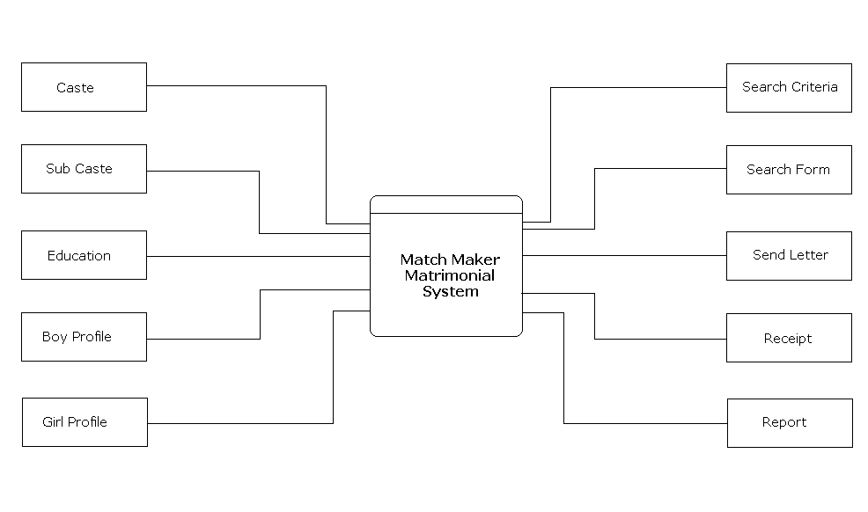
DATA FLOW DIAGRAM

A Dataflow Diagram also known as “Bubble Chart” is used to clarify System requirements and identifying major transformations that all become programs in System Design

Data Flow Diagrams (DFDs) model events andprocesses(i.e. activities which transform data) within a system. DFDs examine how data flows into, out of, and within the system.

Another way of looking at it is that, DFDs are used to answer the following data-oriented questions about a target system:

What processing is done? When? How? Where? By whom?
What data is needed? By whom? for what? When?

DFD Principles
• The general principle in Data Flow Diagramming is that a system can be decomposed into subsystems, and subsystems can be decomposed into lower level subsystems, and so on.
• Each subsystem represents a process or activity in which data is processed. At the lowest level, processes can no longer be decomposed.
• Each 'process' (and from now on, by 'process' we mean subsystem and activity) in a DFD has the characteristics of a system.
• Just as a system must have input and output (if it is not dead), so a process must have input and output.
• Data enters the system from the environment; data flows between processes within the system; and data is produced as output from the system

SYMBOLS

Data Source/Destination

Process

Data Storage

Flow of data
Data Flow Diagram Login Process

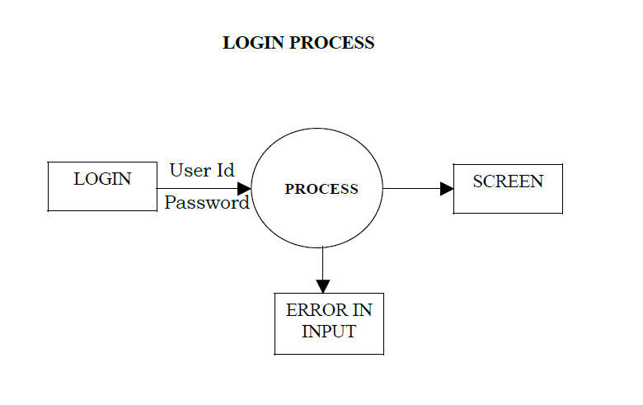
Level 1 Data flow Diagram

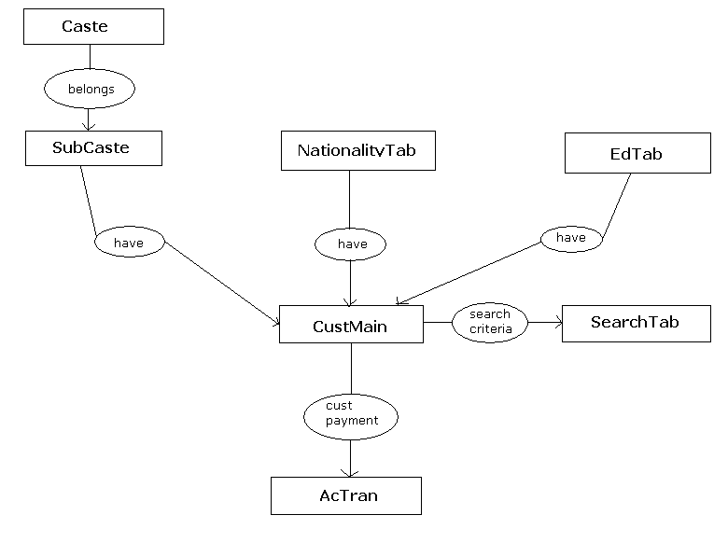
System Design

A computer procedure is a series of operations designed to manipulate data to produce outputs from a computer system. The procedure may be a single program or a series of programs. The detail design of the computer procedure follows acceptance by management of an outline design proposal. The aim now is to design procedures at lower levels of detail, which will define the detailed steps to be taken to produce the specified computer output. When complete, these procedure definitions together with data specifications are organized for programmers from which the required programs can be written.

Design Tools:

Various tools are being used by system analysis to specify computer procedures. Not all of them are used here to design this project. Some of the important tools that have been made use of are:

- Entity relationship Diagram.
- Input design.
- Output Design.
- Database Design.

Input design:

Input design is a part of overall system design, which requires very careful attention. Often the collection of input data is the most expensive process of the system. In terms of both the equipment used and the number of people involved, it is the point of most contact for the users with the computer system; and it is prone to error. If data going into the system is incorrect, then the processing and output will magnify their errors.
One of the early activities of input design is to determine the nature of the input data. This is done partially in logical system design but it now needs to be made more explicit.

Error avoidance and Detection:

Every effort must be made to ensure that input data remains accurate from the stage at which it is recorded and documented to the stage at which the customer accepts it. While every effort is made to avoid errors during the preparation of input data, a proportion of errors are likely to be present.

The user is free from the anxiety of keeping the uniqueness of the primary key since the system itself generates the primary key for the user.

As soon as the user keys erroneous data in, the system just will not accept the data and provides appropriate messages.

Data validation:

Computer input procedures must also be designed to detect errors in the data at a lower level of detail which is beyond the capability of the control procedures. These are combined with the design of the input process itself.

The validation procedure must be designed to check each record, data item, field against certain criteria specified by the system analyst or the programmer.

Output design:

The specification of user requirements is the starting point for the appraisal and the detailed physical design must be done in the light of this and with continuing user involvement. The normal procedure is to design the outputs in detail first and then to work back to the inputs. The outputs can be in the form of operational documents, lengthy reports, and replies to queries or summarizing graphs.
Outputs from computer systems are required primarily to provide a permanent copy of the results for later consultation. Any data item not yet defined must be identified and recorded before output design can proceed. There is often a need at output to provide totals at various levels. It is not always desirable to print or display data as it is held on a computer. The system analyst must ensure whether the form in which it is stored in the system is suitable for the output.

In proposed system the users have been provided with many outputs in the form of messages and alerts so as to help the user enter the correct data.

Reports:

Reports enhance the application programmer’s effort to output the formatted data in a manner practical for the user. This also helps to create hard copy of the valid information.

Entity Relationship Diagram

In software engineering, an entity-relationship model (ERM) is an abstract and conceptual representation of data. Entity-relationship modeling is a database modeling method, used to produce a type of conceptual schema or semantic data model of a system, often a relational database, and its requirements in a top-down fashion. Diagrams created by this process are called entity-relationship diagrams, ER diagrams, or ERDs.

Data flow diagrams can be used to provide a clear representation of any business function. The technique starts with an overall picture of the business and continues by analyzing each of the functional areas of interest. This analysis can be carried out to precisely the level of detail required. The technique exploits a method called top-down expansion to conduct the analysis in a targeted way.

The result is a series of diagrams that represent the business activities in a way that is clear and easy to communicate. A business model comprises one or more data flow diagrams (also known as business process diagrams). Initially a context diagram is drawn, which is a simple representation of the entire system under investigation. This is followed by a level 1 diagram; which provides an overview of the major functional areas of the business.
ER Diagram Symbols

ENTITY

RELATIONSHIP

KET ATTRIBUTE

ATTRIBUTE

ER Diagram

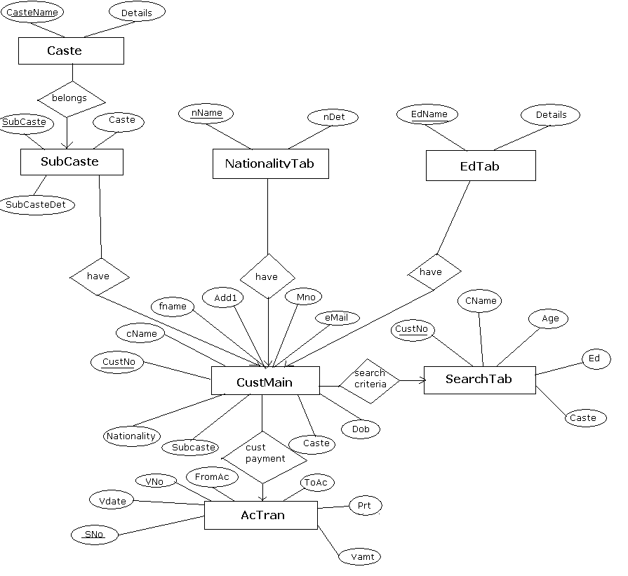
Data Dictionary
Database Design:

The database contains the following entities and attributes.

Table Name(Entity) | Fields(Attributes)
AcTran | Vno,Vdate,froma/c,toa/c, amount,particulars,remarks
AcTranTemp | Vno,Vdate,froma/c,toa/c, amount,particulars,remarks
CasteTab | Caste,CasteDet
CustMain | CustNo,cname,fname,Add1Add2,  Add3,Add4,pin,pNo,Mno,email,dob,cHeight,  CWeight,Ed,Caste,SubCaste,Religion,Disgn,  Company,Sal,PrDet,OtherDet,Gender
EdTab | EdName,EdDetails
NationalityTab | NName,Ndetails
SearhDet | CustNo,Cname,Age,Ed,caste,Religion
SubCasteTab | Caste,SubCaste,SubCasteDet
Users | Sno,UserName,Password

Definition of data requirements

The tables will contain the following data:

Table Name : AcTran
This table is used for account transactions

Attribute Name | Comments | Data type and Length | Validation
SNo | Automatically incremented | Number,long integer | Unique Primary key
Vdate | Voucher Date | Date/time
VNo | Voucher No, generated by the system | Number,Long Integer
FromAc | From the customer | Text(50)
ToAc | To card/cash/credictcard | Text(50)
Prt | Particulars about the amount paid | Text(250)
Vamt | Voucher Amount | Text(50)
Remarks | Remarks any | Text(50)

Table Name : Caste
Table Caste:This table is used store caste details

Attribute Name | Comments | Data type and length | Validation
Caste | To enter caste | Text(50) | Unique Primarykey
Caste Details | To enter caste details | Text(50)

Table Name : CustMain

Table CustMain :This Customer table used store all customer details

Attribute Name | Comments | Data type and length | Validation
CustNo | Custmernumber(System generated) | Number,Long Integer | Unique Primary key
cName | Custmer Name | Text((50) | Mandatory field
fname | First name | Text(50)
Add1 | Address | Text(100)
Add2 |  | Text(100)
Add3 |  | Text(100)
Add4 |  | Text(50)
Pin | Pincode | Text(50)
PNo | Phone Number | Text(50)
Mno | Moblie Number
eMail | email | Text(50)
Dob | Date of birth | Date/time
cHeight | Customer Height | Text(50)
cWeight | weight | Text(50)
Caste |  | Text(50)
Subcaste |  | Text(50)
Nationality |  | Text(50)
Disgnation |  | Text(50)
Company |  | Text(50)
Sal | Salary details | Text(50)
ProDet | Property details | Text(250)
OthDet | Other details | Text(250)
Gender |  | Text(1)

Table Name : EdTab

EdTab:This table is used to store education details

Attribute Name | Comments | Data type and length | Validation
edName | Education Name | Text(50)
EdDet | Education Details | Text(50)

Table Name : NationalityTab

NationalityTab: This table is used to store nationality details

Attribute Name | Comments | Data type and length | Validation
nName | Nationality name | Text(50
nDet | Nationality details | Text(50)

Table Name : SearchTab

SearchTab: This table is used to store customer search preferences.

Attribute Name | Comments | Data type and length | Validation
CustNo |  | Number,long integer
CName |  | Text(50)
Age |  | Text(50)
Ed | Education | Text(50)
Caste |  | Text(50)
Religion |  | Text(50)

Table Name : SubCaste

SubCaste: used to store subcaste details

Attribute Name | Comments | Data type and length | Validation
Caste |  | Text(50)
SubCaste |  | Text(50)
SubCasteDet |  | Text(150)

Table Name : UsersTab

Users: This table is used to store Users details

Attribute Name | Comments | Data type and length | Validation
Sno | Automatically incremented | Number,byte | Primarykey
UserName |  | Text(50)
PWord | password | Text(50)

ARCHITECTURAL DESIGN

Architectural design represents the structure of data and program components that are required to build a computer based system. It considers the architectural style that a system will take, the structure and properties of the component that constitute the system, and the inter relationships that occur among all architectural components of a system.

Although a software engineer can design both data and architecture, the job is often allocated to specialists when large, complex systems are to be built. A database or a data warehouse designer creates the data architecture of a system. The system architect selects an appropriate architectural style for the requirements derived during system engineering and software requirements analysis.

Architectural design begins with data design and then proceeds to the derivation of one or more representations of the architectural structural of the system. Alternative architectural style or patterns are analyzed to derive the structure that is best suited to customer requirements and quality attributes. Once an alternative has been selected, the architecture is elaborated using an architectural design method.

An architectural model encompassing data architecture and program structure is created during architectural design. In addition, component properties and relationships are described.

TESTING

This section deals with the details of the classes of tests which must be conducted to validate the functions, performance, and the constraints. This is achieved basically by the means of testing which plays a vital role in the development of the software. The various low level testing which can be grouped on a broader sense are discussed as below:

- Unit Testing: Testing of each and every module individually is called unit testing. Each module is designed and executed so that it works independently and generates some relative output. Unit testing of a module results in a set of individually executing modules that generates its independent output. The modules in this project i.e. purchases, sales, returns, cash and bank transactions, stock status and others are individually tested.

- Integration Testing: Integration testing is one in which the modules are combined with one another to synchronize the outputs and co-ordinate the flow of control. Each module is coalesced with other module to establish proper connectivity between the two modules. All the individual modules have been integrated and tested.

- Validation Testing: Validation testing deals with testing that whether the validations are justified and all the requirements are fulfilled logically as per the requirements as the validations are designed according to the requirements of the application – an approach to the problem in a logical and relational manner. All the validation testing have been done (like only the numbers should be accepted in the phone number , amount , bill no fields ,quantity and other related fields, similarly for the text to accepted only in related fields like the names and other related fields). The stock validation is the major validation that keeps track of the products dealt and the reorder levels.

- System Testing: Testing the whole system i.e. verifying and validating the whole source code to check if the system as a whole is executing is called system testing. The proposed system undergoes it under all conditions to be called a successful system.

Test plan

Test  No | Test | Expected Result
1 | Test user name & password | Only “Admin “ as username and match as password accepted. Main menu opens automatically.
2 | Test Main menu options | All the forms opens
3 | Test Master Entry options  For caste, sub caste, nationality,  Education and user entry forms. To enter a new record modify and delete options | All forms working
4 | Test for subcaste form to ensure that all the caste details should come into caste combo box | All previous caste details should come from the caste table into the form so that user can select the caste details
5 | Test for list boxes in the master forms should display the records from table | working
6 | Test for the visibility of the buttons in the master forms.  New and close buttons should be enabled and all other buttons are disabled when form loaded | Only new and close buttons are enabled when form loaded and modify ,delete and save buttons are disabled
7 | Test for displaying the required record from the table to the form fields (for all the forms )Double click the required record in list box or data grid | The record is displayed in the form
8 | Test for close of forms to back to MDI form | Form should be closed when close button clicked (applied for all the forms)
9 | Test for main form exit option | Should close the system
10 | Test for visibility of command buttons when Customer entry form loaded. New, close ,print buttons enabled and modify delete and save buttons disabled | Form opened in designed format
11 | Test for automatic generation of custNo when new button clicked in Customer Entry form | CustNo incremented and generated automatically and can not be changed.
12 | Test for mandatory field entry in customer entry form for the field Customer name | should display the message “please enter the boy/girl name”, When no value entered in custname field.
13 | Test for modify, delete operations for all the forms having modify and delete operations | Should modify the record when modify operation clicked, delete the record when delete clicked (applied for all the forms having modify and delete operations)
14 | Test for all combo boxes in all forms for getting the previous details in the combo box | Showing the required fields in the combo box when combo box clicked( eg education ,nationality caste combo boxes in customer entry form)
15 | Test for getting required subcaste details of a caste when caste is clicked from caste combo box clicked | Correctly showing the corresponding subcaste details when caste clicked
16 | Test for Search Criteria form to save the details of search criteria for a customer | Saving the record
17 | Test for Search form to display the records in the data grid when search button clicked depends on parameters, boy or girl, age,education caste and religion | Depending on parameters showing required records in the data grid .
18 | Test for search report | Report printed correctly when print option clicked
19 | Test for search of required records of customer when CustNo is entered and search button clicked in send letter form | Display the required records(the according to the customer interests stored in search table) for the entered CustNo.
20 | Test for Send letter report | Report printed correctly
21 | Test for Account voucher entry form for automatic generation of voucherno when new button clicked | Voucher no automatically generated
22 | Test for Visibility of the  Account voucher form. New, find close buttons enabled and modify, delete and save buttons disabled | New,find and close buttons enabled and modify, delete save buttons are disabled
23 | Test for find and hide and refresh buttons in Account voucher entry form. | Displaying the required records in the data grid depending on parameters(from date,to date). Refresh and hide options are working  Hide button should hide the data grid
 | Test | Expected Result
24 | Test for print options in all forms | All reports printed correctly
25 | Test for all the reports | Reports printed correctly
 | Test for display details and print buttons in Account  Reports form. | Display details button enabled and print button disabled
27 | Test for Accounts Report form  To display record when display details button clicked . | Displaying the records (from date to to date )in the data grid when display details clicked.  Print button enabled
29 | Test for Account details report | Report printed correctly
30 | Test ‘recovery ‘ after power failure | Only current changes lost
Test Results

Test 1: test user name and password
When the user enters correct user name and password then only the system opened, otherwise the following message was displayed.

Test 2: visibility of command buttons for Caste form
When new button clicked save is enabled and curser placed in first text box. Caste details entered and saved.

Test 3: visibility of buttons modify delete when record dragged from list box to the form fields.

Test 4: Test for Modification of Caste details:
The record is modified and the modify delete and save buttons disabled and new button enabled.

Test 5: Delete record from Caste
When delete option is clicked it displays the message and if we select the ok option to delete then deletes the record. The same test results examined for all the forms having new/modify/delete and save options.

Test 6: To check for system generated CustNo and mandatory field check
When user clicks new option it generates a new CustNo for the customer.
When the user leaves the name filed empty then the screen displays the following message to enter the data.
Tested for caste, sub caste and religion forms also to display the details in combo box.

Test 7: Saving the search criteria for the customer
This ensures that record is saved successfully. When save button clicked the record is saved and displays the above message.

Test 8: To display all the boys whose education is B.A.
On execution it found that it searches based on education criteria.

DATA VALIDATION

Data validation, is a very important part in any application involving a database. We have to be aware of the specifications of the database organization and also about the kind of data that goes into the database. We have to provide for stringent error checking, in order to discard invalid data and prevent it from getting it into the database.

Data validation can be done in two places. While creating the database schema, we can specify certain integrity constraints that have to be maintained b/w various relations in the schema. This ensures that no insertion, deletion and update anomalies creep in during operation. Data validation can also be done at the interface itself, to provide more robust level of data validation. For example, in the login form whose loginid has been established by the administrator will be given login permission. This can be trapped at the interface level itself. And in the form, to modify the user profile, the administrator is allowed to modify only if that loginid has need permission.

Some Examples of Data Validation done in this project are:

- Invalid loginid cannot be entered.
- Invalid Address, such as door no, etc (advance > balance or negative) cannot be entered.
Future Development
At this stage of time when the whole world is running after advanced technology in every aspect of life and to comfort man’s life these small electronic machines like computers have become as indispensable part of our lives. The project broadband services covers various information required by user.
In future we hope that this demonstration model can be further improved so that it will define more things about broadband services so the users are further benefited.
We can also implement forum to discuss, discussion between technical people of the company and the end user.

We can also implement online payment system, through which people can make their payment. The payment which occurred due the usage of broadband services.

CONCLUSION

Computer is the magic word of today’s world. The object of “Matchmaker Matrimonial System” project is to harness the power of the computer for our practical and potential need. This report expected to extensively cover this concept and plant a seed of inquisitiveness in the minds of the users.

We are thankful to all the people who have given us their hearty support in this endeavor, we again thank out college for providing us all the facilities and thanks to our beloved Coordinator Mr. G. Somashekar and to our guide

Ms. Jyothsna Rathnakar
Screen Shots

Welcome Screen

